**Bachelors of Domination**

Game Manual

**TABLE OF CONTENTS**

**Introduction.………………………………………………………………………………………….2**

**Main Menu…...……………………………………………………………………………………….3**

**Game Setup.………………………………………………………………………………………….4**

**Options…….………………………………………………………………………………………….5**

**In Game User Interface HUD………………………………….…………………………..……….6**

**Gameplay….………………………………………………………………………………………….7**

**Controls…....…………………………………………………………………………………………9**

**Introduction**

In the year 2100 the University of York has been completely taken over by the students.

The campus was initially split in different sectors which were then assigned equally between all colleges. However, given the super competitive nature of students, strong rivalries soon started and eventually lead to an all out, (non-violent) war between colleges.

Now it’s your time to step in and lead your favorite college to victory, managing the troops in the field and conquering every sector at The University of York.

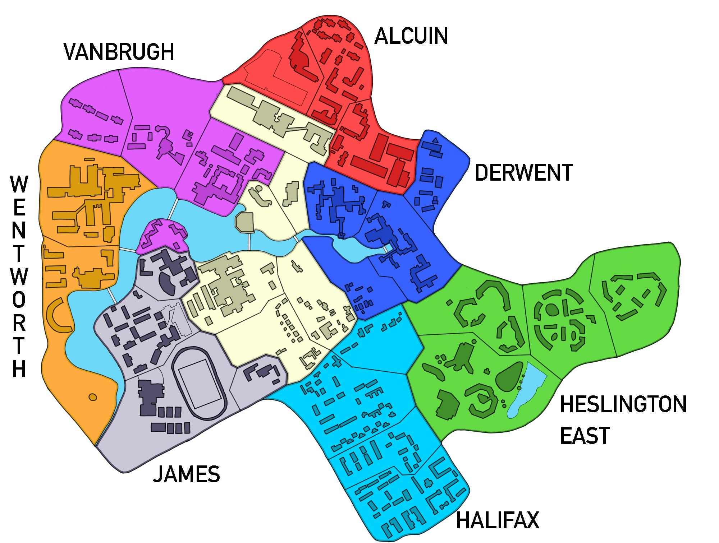

**Main Menu**

When you launch the game you will enter the Main Menu, use it to start a New Game or access the Options.

Loading a saved game has not been implemented yet.

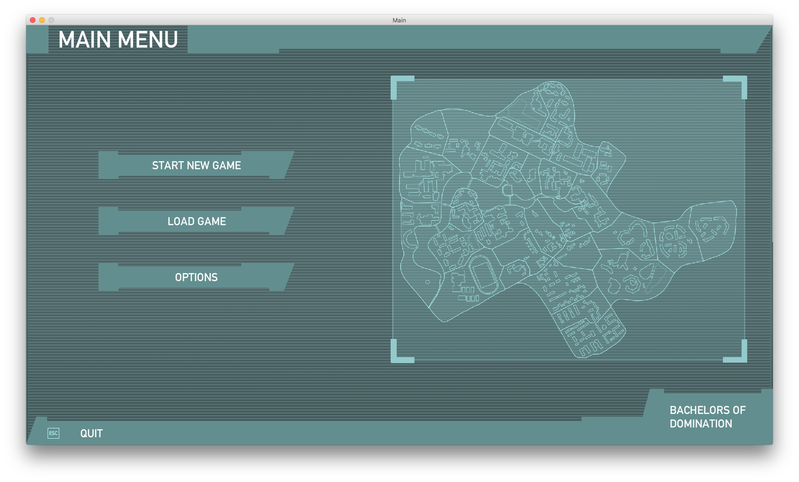

**Game Setup**

When setting up a new game you may configure it to your liking. You may choose:

* How many players are in the game (2 - 4)
* The name of each player and the college they belong to
* If a 120 second turn timer is enabled
* If a neutral player is in the game, (required for 2 player games)

### Player Setup

On the left side of the menu you can enable up to four players by clicking on the arrow buttons.

On the right side of the menu you can enter the respective player name by clicking on the player label and typing. The player’s college is chosen by clicking on the arrow buttons and each college is associated with a specific color used to signal which sectors a player owns.

Available colleges:

* Alcuin Red Colour
* Derwent Blue Colour
* Halifax Cyan Colour
* Heslington East Green Colour
* James Grey Colour
* Vanbrugh Purple Colour
* Wentworth Orange Colour

On the bottom left there are two switches: the first one enables the “Neutral Player” and the second one enables the “Turn Timer”. When the “Neutral Player” is enabled all the default neutral sectors are allocated to it. The neutral player does not attack but simply defends its sectors. Enabling the turn timer restricts a player to only 120 per turn.

When you are ready you can start the game by clicking on the “Start Game” button. A minimum of two players is required to play the game, and each player must select a different college and have a different name.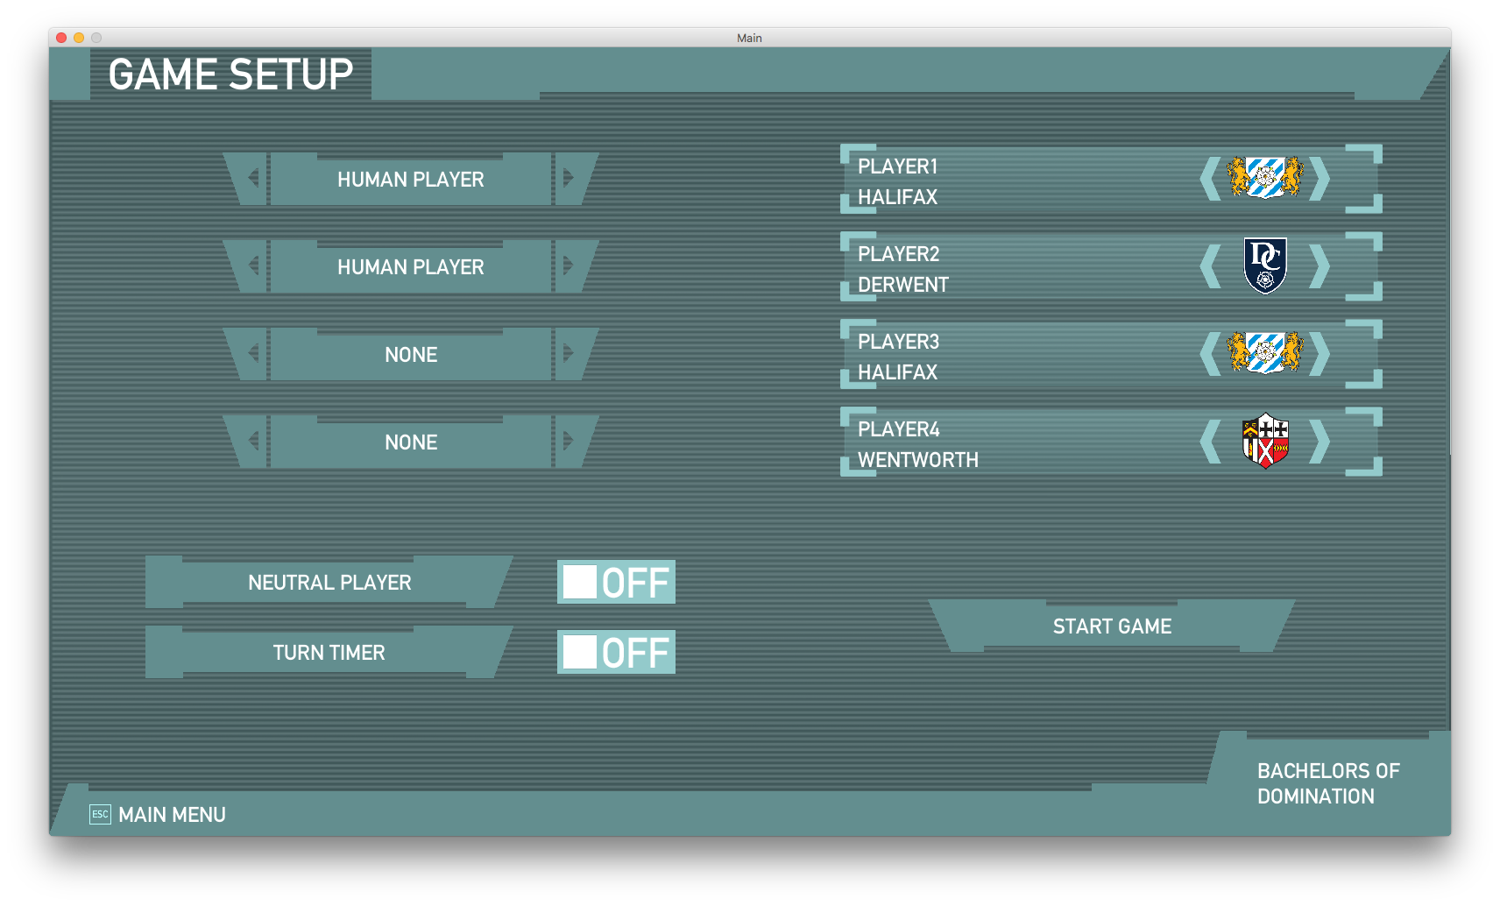

**Options**

The options menu allows you to configure how the game runs. The user can set the audio volume, display resolution, fullscreen or not and enabling colour blind mode.

Whilst the UI widgets exists for configuring the audio and colourblind mode these are currently not implemented.

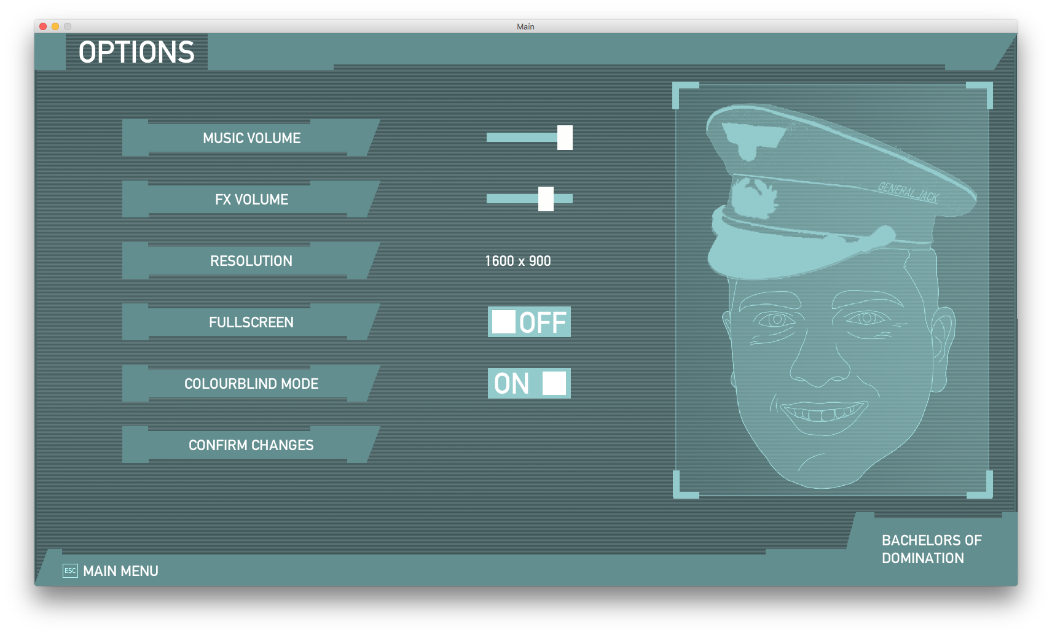

**In Game User Interface HUD**

The in game user interface consists of 3 parts: the top bar; the game map and the bottom bar. The top bar indicates which phase of the current player’s turn they are in. The game map shows the current state of the game where the sector colour shows who owns it, each sector contains a circle with a number which indicates the amount of troops allocated to it. Finally, the bottom bar shows information about which player’s turn it is; how much time they have remaining in their turn and details about the sector the mouse is currently hovered over.

The Top Bar of the HUD displays all three phases of the turn. The current phase is represented in uppercases. The Quit button allows to return to Main Menu.

The Bottom Bar of the HUD shows information about the player currently playing. If enabled, the turn timer shows the time remaining for the turn.

As you hover on a sector the bottom bar will also display information about the specific sector.

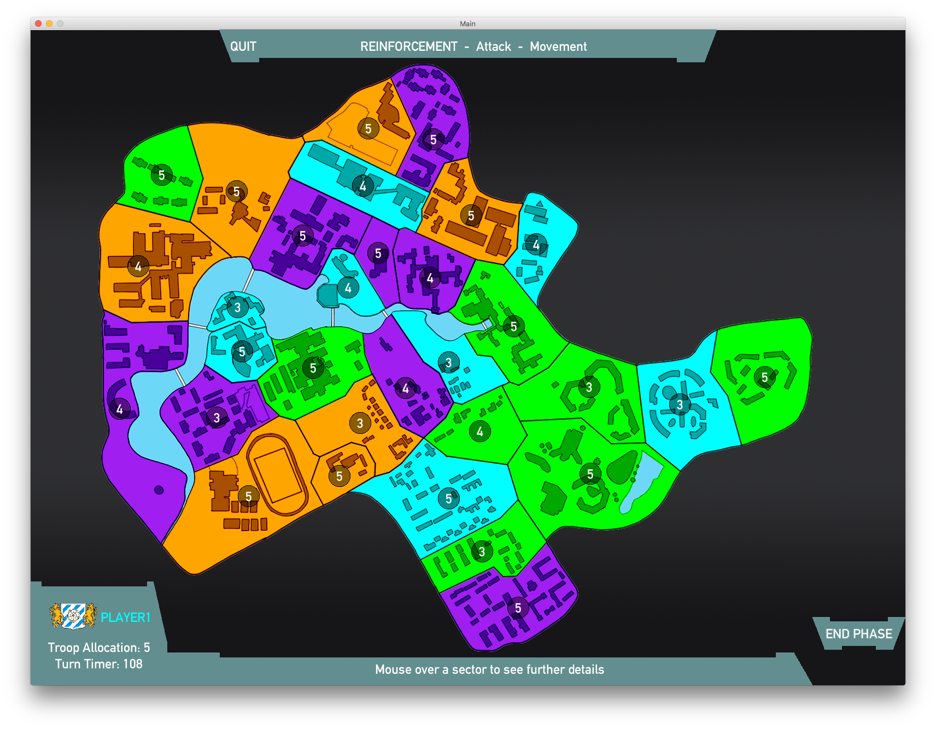

**Gameplay**

Each turn is divided into three phases: Reinforcement, Attack, Movement(Not Implemented Yet).

You can skip a phase by clicking on the End Phase button.

In the Reinforcement phase you can add troops to any of your sectors, by clicking on a sector and then using the slider in the dialog box to choose the number of troops to allocate.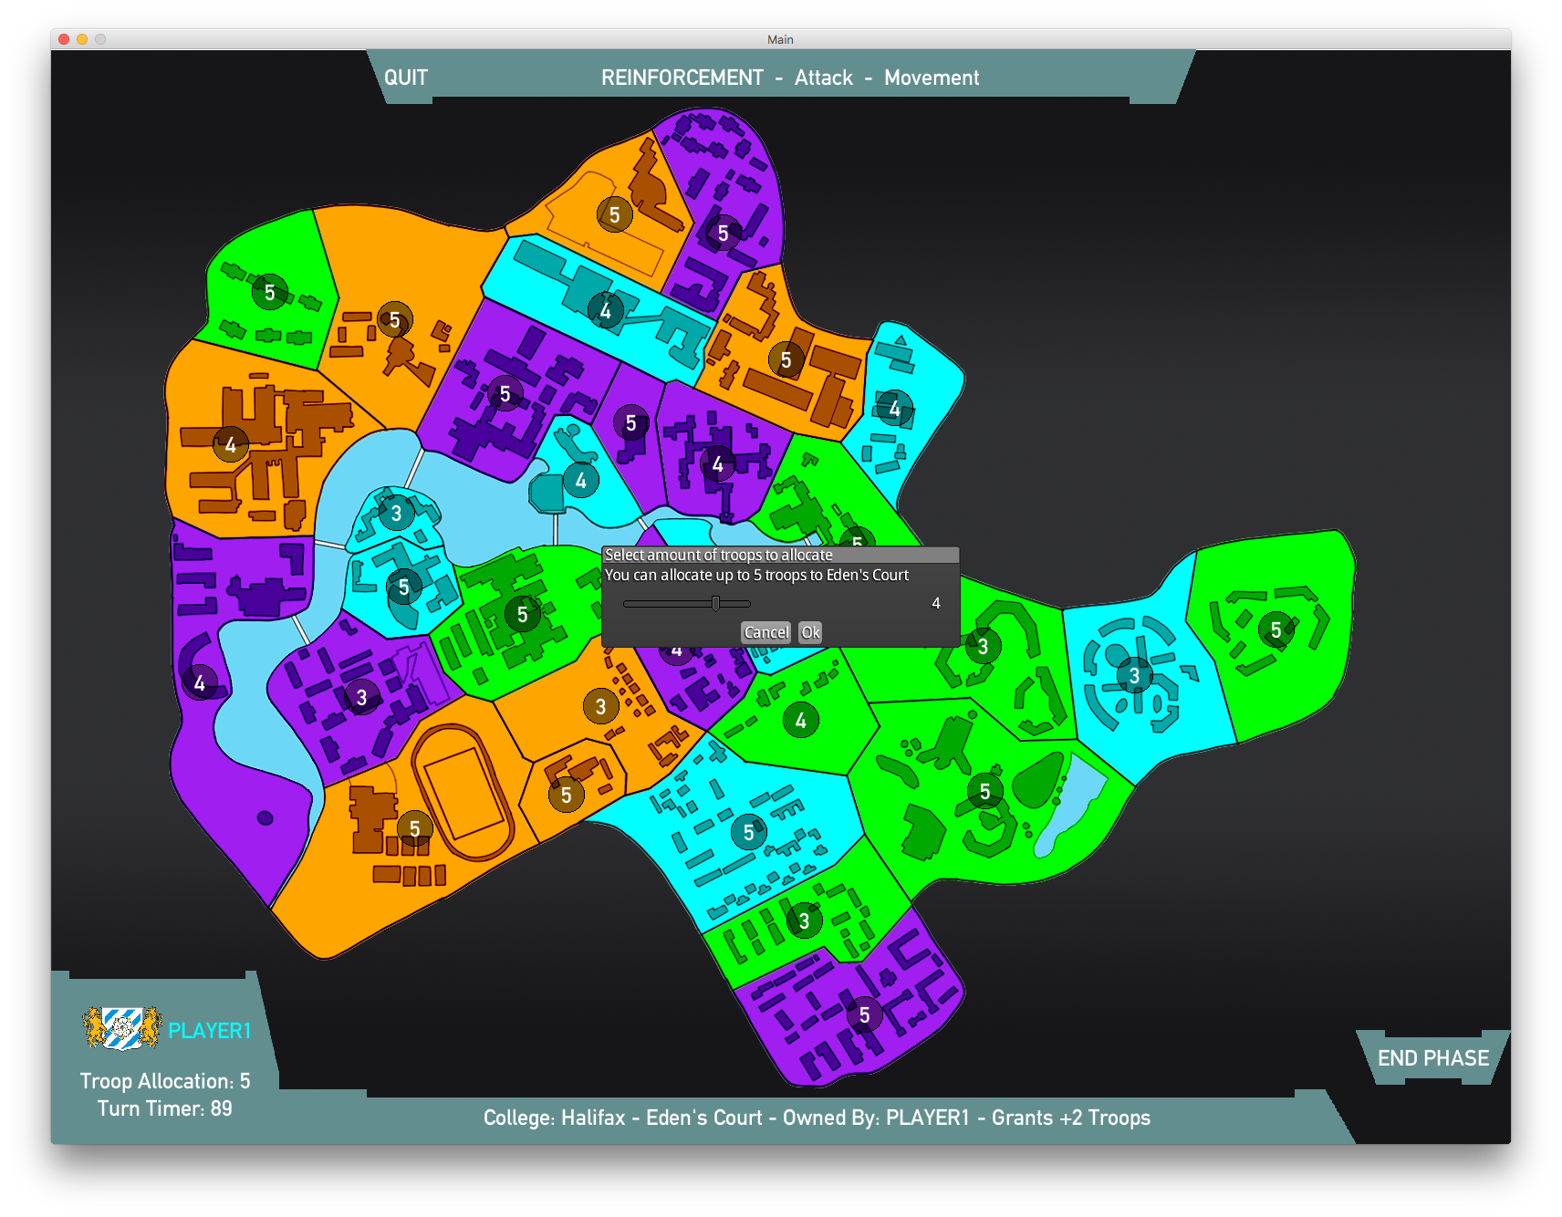

In the Attack Phase you can attack enemy sectors, simply click and drag from your sector to the enemy sector you want to attack. A dialog box will prompt you to select the number of troops to attack with. The result of the attack is mainly determined by the difference in strength between the sectors, but you will still need a bit of luck to succeed.

If you manage to conquer the enemy sector, you will be asked how many troops you wish to move to it.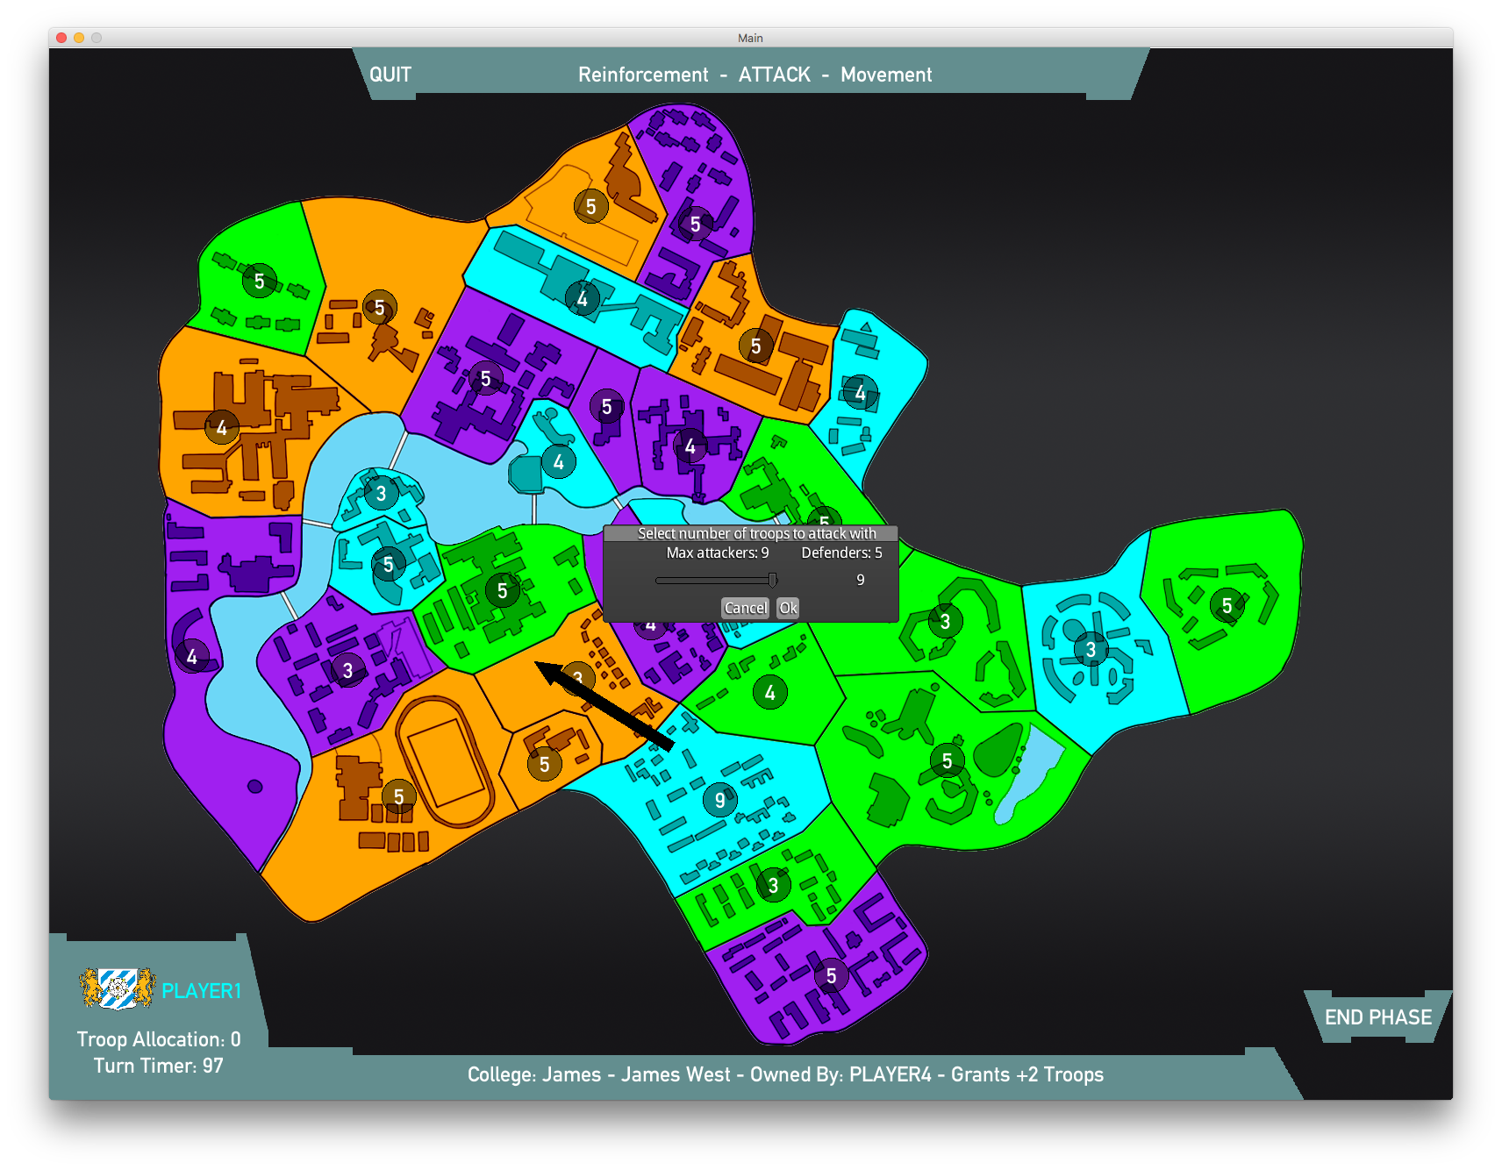

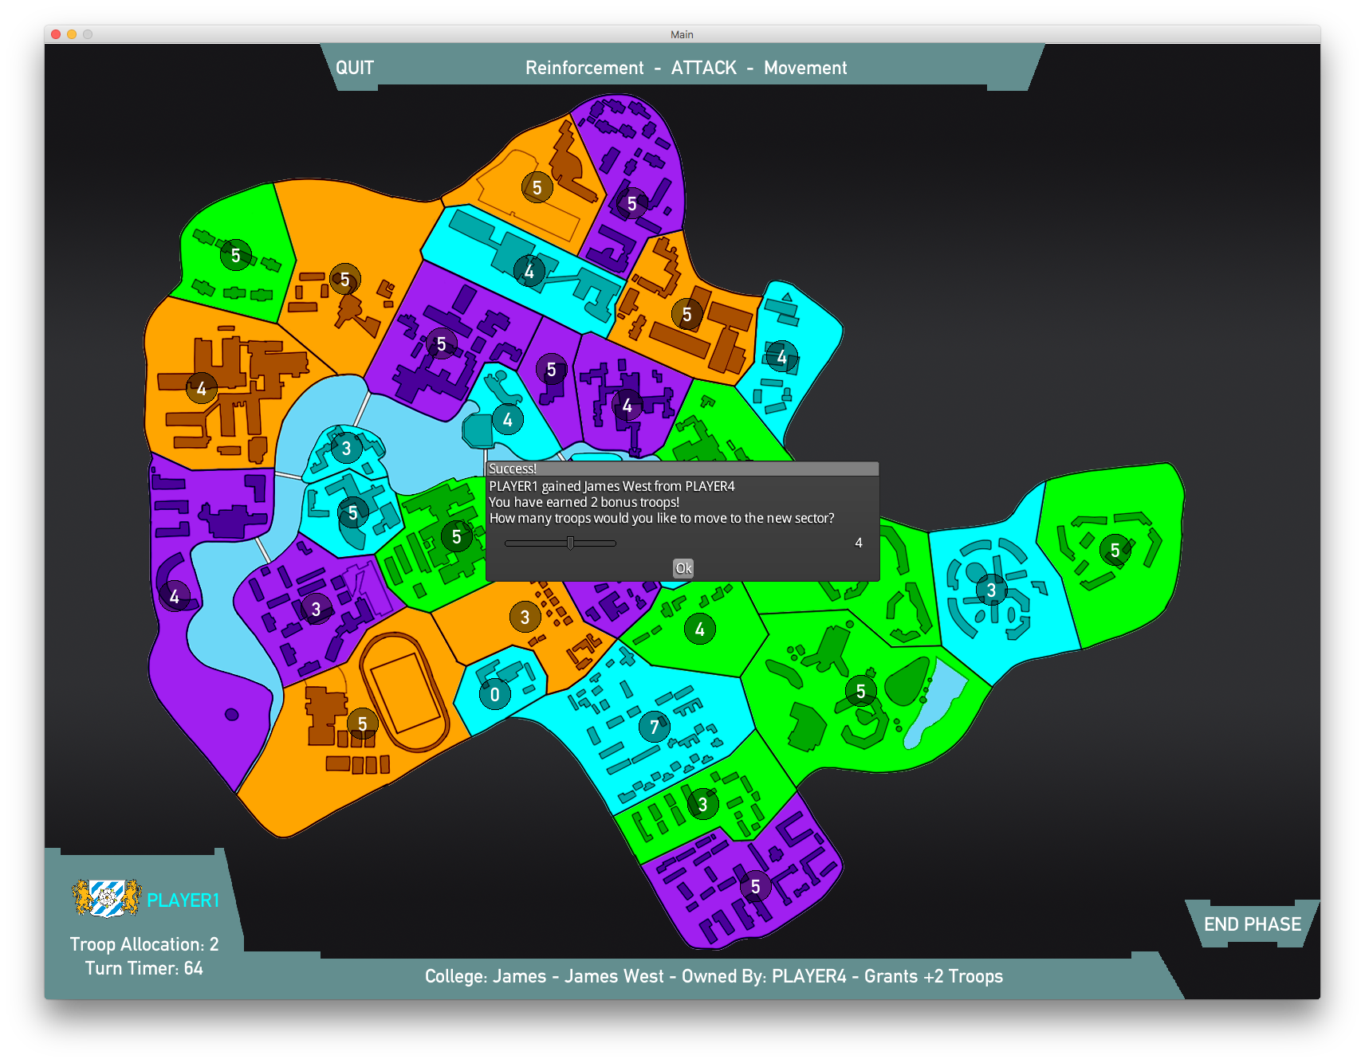

**Controls**

|  |  |
| --- | --- |
| Left Click | Press buttons and perform actions on sectors |
| Esc Key | Return to Main Menu and quit game |
| Arrow Keys | Move the game map |
| Scroll Wheel | Zoom in and out of the map |